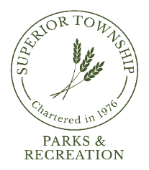

PARKS & RECREATION COMMISSION REGULAR MEETING
SEPTEMBER 23, 2024 @ 6:30 P.M.
AGENDA

- CALL TO ORDER
- ROLL CALL
- FLAG SALUTE
- AGENDA APPROVAL
- PRIOR MEETING MINUTES APPROVAL
  - August 26, 2023

- CITIZENS PARTICIPATION

- REPORTS
  - Chairperson
  - Director
  - Board Liaison
  - Board Meeting Attendee
  - Park Steward
  - Safety

- COMMUNICATIONS
  - Educational; Unwind with Parks & Recreation
  - Ducks Unlimited Wetland Conservation Program Grant Letter
  - Washtenaw County 2025-29 Master Plan Review

- OLD BUSINESS
  - Fireman’s Park Improvements Update
  - “Rock” Property Committee Update
  - 2025 Budget Preparation

- NEW BUSINESS
  - ARPA Funds Allocated to Parks & Recreation
  - Volunteers; Forest Forensics, Saturday, October 5th 1:00pm
  - Volunteers; Pumpkin Carving, Saturday, October 26th, 11:00am – 2:00pm

- BILLS FOR PAYMENT
  - August 27, 2024 – September 16, 2024

- FINANCIAL STATEMENT
  - August 2024 Revenue & Expenditure Report

- PLEAS AND PETITIONS
- ADJOURNMENT

Next Meeting: Monday, October 21, 2024 @ 6:30pm

