
-
SUPERIOR TOWNSHIP
PARKS & RECREATION
VOLUNTEER TREE PLANTING

AND
KITE & ROCKET DAY

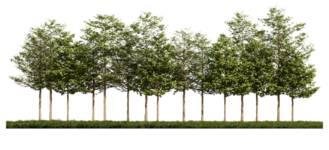


SATURDAY, APRIL 26^{th,}
10:00am - 2:00pm
RAIN DATE: April 27th
FIREMANS PARK
8795 MACARTHUR BLVD.
10:00 AM- BEAUTIFY FIREMANS PARK BY PLANTING TREES NOON- BUILDING AND FLYING KITES YOU CAN TAKE HOME
LUNCH WILL BE PROVIDED FREE AT NOON
(734) 480-5502 FOR ADDITIONAL INFO
WHILE SUPPLIES LAST

