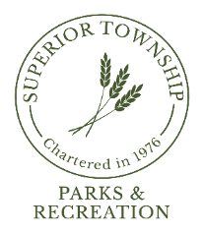

**PARKS & RECREATION COMMISSION SPECIAL MEETING**

**OCTOBER 7, 2024 @ 6:30 P.M.**

**AGENDA**

1. **CALL TO ORDER**
2. **ROLL CALL**
3. **FLAG SALUTE**
4. **AGENDA APPROVAL**
5. **NEW BUSINESS**
   1. 2025 Parks & Recreation Budget; PROPOSED
   2. 2025 Parks & Recreation Budget Explanations
6. **PLEAS AND PETITIONS**
7. **ADJOURNMENT**

**Next Meeting: Monday, October 28, 2024 @ 6:30pm**