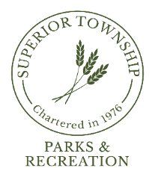

**PARKS & RECREATION COMMISSION REGULAR MEETING**

**SEPTEMBER 23, 2024 @ 6:30 P.M.**

**AGENDA**

1. **CALL TO ORDER**
2. **ROLL CALL**
3. **FLAG SALUTE**
4. **AGENDA APPROVAL**
5. **PRIOR MEETING MINUTES APPROVAL**
   1. August 26, 2023
6. **CITIZENS PARTICIPATION**
7. **REPORTS**
   1. Chairperson
   2. Director
   3. Board Liaison
   4. Board Meeting Attendee
   5. Park Steward
   6. Safety
8. **COMMUNICATIONS**
   1. Educational; Unwind with Parks & Recreation
   2. Ducks Unlimited Wetland Conservation Program Grant Letter
   3. Washtenaw County 2025-29 Master Plan Review
9. **OLD BUSINESS**
   1. Fireman’s Park Improvements Update
   2. “Rock” Property Committee Update
   3. 2025 Budget Preparation
10. **NEW BUSINESS**
    1. ARPA Funds Allocated to Parks & Recreation
    2. Volunteers; Forest Forensics, Saturday, October 5th 1:00pm
    3. Volunteers; Pumpkin Carving, Saturday, October 26th, 11:00am – 2:00pm
11. **BILLS FOR PAYMENT**
    1. August 27, 2024 – September 16, 2024
12. **FINANCIAL STATEMENT** 
    1. August 2024 Revenue & Expenditure Report
13. **PLEAS AND PETITIONS**
14. **ADJOURNMENT**

**Next Meeting: Monday, October 21, 2024 @ 6:30pm**