SUPERIOR TOWNSHIP
PARKS & RECREATION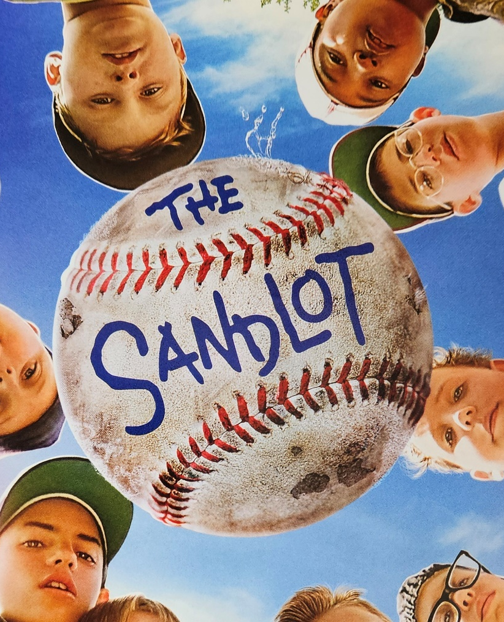
MOVIES IN THE PARK
Saturday, August 10th @ Oakbrook Park
8460 Berkshire Dr. east of Prospect Rd.
Enjoy a family friendly game of kickball at 8:00pm where everyone gets to play, followed by a 9:00pm showing
of THE SANDLOT on a Giant 20’ screen.
Bring your picnic blankets, chairs, coolers, and snacks!
KONA-ICE will be on site selling frozen treats & South Point Scholars Will Have Free Popcorn!
(NO ALCOHOL ALLOWED)

