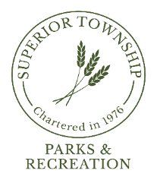

PARKS & RECREATION COMMISSION REGULAR MEETING
MAY 28, 2024 @ 6:30 P.M.
AGENDA

- CALL TO ORDER
- ROLL CALL
- FLAG SALUTE
- AGENDA APPROVAL
- PRIOR MEETING MINUTES APPROVAL
  - April 22, 2023

- CITIZENS PARTICIPATION

- REPORTS
  - Chairperson
  - Director
  - Board Liaison
  - Board Meeting Attendee
  - Park Steward
  - Safety

- COMMUNICATIONS
  - MDHHS Press Release; Staying Healthy During Poor Air Quality Days

- OLD BUSINESS
  - Community Center Advisory Committee Update
  - Ypsilanti Township Community Center
  - Fireman’s Park Improvements Update
  - Park Maintenance Staff Restroom Construction Update

- NEW BUSINESS
  - Resolution 2024-02; Rock Property
  - Detroit Greenbelt Proposal
  - Volunteers
    - Superior Day, Saturday, June 8th
    - Kite & Rocket Day/Fireman’s Ribbon Cutting, Saturday, June 22nd
  - Ypsilanti Juneteenth Celebration

- BILLS FOR PAYMENT
  - April 23, 2024 – May 28, 2024

- FINANCIAL STATEMENT
  - April 2024 Revenue & Expenditure Report

- PLEAS AND PETITIONS
- ADJOURNMENT

Next Meeting: Monday, June24, 2024 @ 6:30pm

