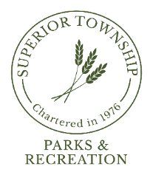

PARKS & RECREATION COMMISSION REGULAR MEETING
APRIL 22, 2024 @ 6:30 P.M.
AGENDA

- CALL TO ORDER
- ROLL CALL
- FLAG SALUTE
- AGENDA APPROVAL
- PRIOR MEETING MINUTES APPROVAL
  - March 25, 2023

- CITIZENS PARTICIPATION

- REPORTS
  - Chairperson
  - Director
  - Board Liaison
  - Board Meeting Attendee
  - Park Steward
  - Safety

- COMMUNICATIONS
  - Resident Email RE: Basketball

- OLD BUSINESS
  - Community Center Advisory Committee Update
  - Ypsilanti Township Community Center
  - Fireman’s Park Improvements Update
  - 2024 P&R Unassigned Funds Budget
  - Park Staff Restroom Bid Award

- NEW BUSINESS
  - Dixboro Village Green; Tom Freeman
  - Birdsong Nature Preserve
  - Community Park Tennis Court Repairs Estimate

- BILLS FOR PAYMENT
  - March 25, 2024 – April 22, 2023

- FINANCIAL STATEMENT
  - March 2024 Revenue & Expenditure Report

- PLEAS AND PETITIONS
- ADJOURNMENT

Next Meeting: Tuesday*, May 28, 2024 @ 6:30pm
*Due to Holiday

