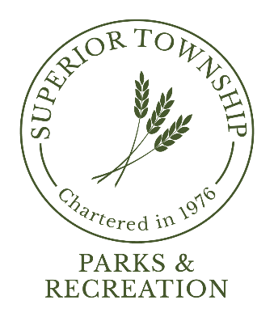

CHARTER TOWNSHIP OF SUPERIOR
PARKS & RECREATION COMMISSION MEETING

The Parks & Recreation Commission
APRIL 2024
Regular Meeting
will be held on
MONDAY, APRIL 22, 2024 @ 6:30 p.m.
at
SUPERIOR TOWNSHIP HALL
3040 N. Prospect Rd.
Superior Township, MI 48198
(N/E Corner of Cherry Hill & Prospect)

Superior Township will provide necessary reasonable auxiliary aids and services to individuals with disabilities upon four (4) business days’ notice to the Township. Individuals requiring auxiliary aids or services should contact Superior Charter Township Parks & Recreation Department.
For additional info call: (734) 480-5502
or email: superiorparks@superior-twp.org

